EUROPEAN CAPITALS TRADE UNIONS’ NETWORK
XIII PERMANENT CONFERENCE ROME 23-25 SEPTEMBER 2013

Rome, March 2013

To the TU of the European capitals:
DGB/Berlin; CSC/Brussels; MSZOSZ/Budapest; BNS/Bucharest; ICTU/Dublin; SAK/Helsinki; GWU/La Valletta; CGTP/Lisbon ; TUC; London; GLATUC/London; CC.OO./Madrid ; LO/Oslo; CGT-CFDT-FO- UNSA/Paris; LBAS/Riga ; LO/Stockholm

In copy to: EKA/Athens; LO/Copenhagen; UGT/Madrid ;
MTUF/Moscow ; SEK/Nicosia ;
CGIL-CISL-UIL /Rome ; PODKREPA/Sofia ; SOLIDARUMAS/Vilnius

Dear colleagues,

the Organising Committee of the 13th Conference of the trade Unions of the Capital cities met in Athens on 14/15 February. The committee members are MTUF- Moscow, CGIL-CISL-UIL Rome and Solidarumas - Vilnius that will be the host of the 2014 conference.
The meeting on Feb. 15th was also attended by LO - Copenhagen, EKA - Athens, UGT - Madrid, SEK - Nicosia and Podkrepa - Sofia according to the formalities of the EU funded project C.Re.A.T.E.S.

After a fruitful and rich debate all attendants agreed upon the following issues:

As for the practicalities:

- the XIII Conference will take place in Rome on 23/25 September 2013. the conference will start in the afternoon on Sep. 23rd and will end at about 6pm on Sep. 25th;
- the conference will be attended by max. 2 delegates from the trade union organisations receiving this invitation;
- travel expenses of each delegate will be reimbursed after the conference up to the amount of 350 €;
- accommodation, meals and simultaneous interpretation (Italian, English, French, Spanish) will be covered with the project funding.

As for the Conference contents:

- the theme of the conference will be “The contribution of the local trade union organisations in the context of the Europe 2020 Strategy”;
- Each trade union must fill out the questionnaire and send it back by 20th May 2013 the latest;
- we will get in touch with the Organisation of the Employers from the capital Cities (OPCE) in order to find out common steps to take in order to foster employment and growth in our territories. We will send you prompt updates about this initiative as soon as they will be available.

We also agreed upon the formalisation of the logo of our network (ECTUN – European Capitals Trade Unions’ Network) which will be autonomous and informal and whose members are the trade union organisations that have participated or will participate in the Permanent conference.

Please do not hesitate to contact us if you need any further information.

In solidarity,

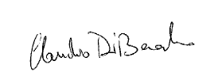

M. Nagaytsev C. Di Berardino M. Bertone P. Bombardieri A. Markevičiu 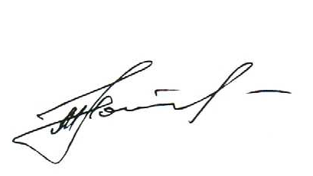 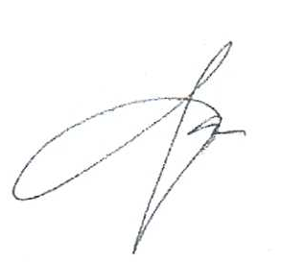

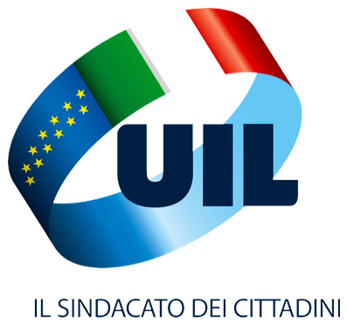
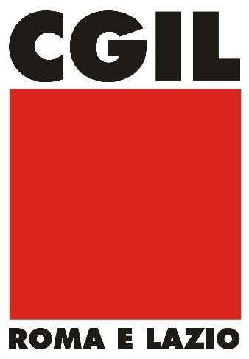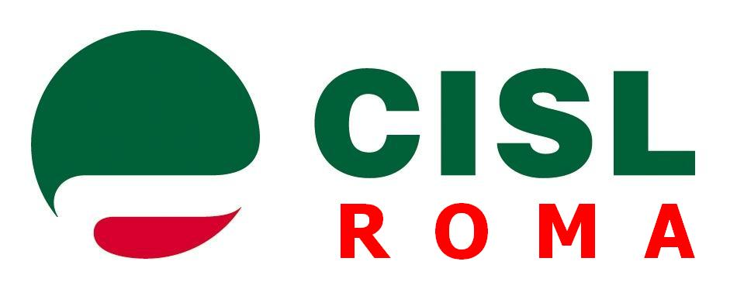
MOSCOW Uil Roma e Lazio VILNIUS

Contact: conferenceroma2013@gmail.com

