Rome, 15 April 2013

For the kind attn of:
International Dept MTUF
121205 Moscow New Arbat, 36
(495) 690 87 60
turkina@mtuf.ru
inter@mtuf.ru

Dear colleagues,

the Organising Committee of the 13th Conference of the trade Unions of the Capital cities has agreed that the XIII Conference will take place in Rome on 23/25 September 2013.
We have the pleasure of inviting the following persons to the conference and following activities on the basis of the ongoing cooperation in the context of our joint commitment in the organisation of the events relating to the project of the Trade Union Organisations of the European Capital cities:

Mr
Mrs
Mr

The follow-up of these events will include further meetings in other EU countries in the next two-year period including the 13th Permanent Conference in September and further possible meetings in 2013-2015 years (one already planned in Copenhagen in November 2013).

In solidarity,

The Secretary General
C. Di Berardino

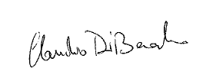

Contact: conferenceroma2013@gmail.com

