ENG

FINAL REPORT

C. Re. a. T.E.S
Capital Regions and Twenty20 European Strategy

CONTENTS

Introduction and methodology 3

1. The survey sample. The structure of the trade unions in the European capital cities 5

2. Capitals, Regions and the Europe 2020 Strategy 10

3. Good practices and final considerations 16

Introduction and methodology

The European Union is going through a phase of deep transformation, above all because of the economic crisis and the globalisation process; these factors are producing strong social repercussions, especially on workers and labour conditions and access to welfare.

The European Union, in order to overcome the crisis and relaunch the Union itself from the social, economic and environmental viewpoint, has developed the Europe 2020 Strategy, which has set itself 5 ambitious targets, to be reached during this decade.

- to bring the employment rate of those in the 20-64 year-old age bracket to 75 %;
- to invest 3 % of the gross domestic product (GDP) in research and development;
- to reduce carbon emissions to 20 %, increase the renewable energy quota by 20 % and increase energy efficiency by 20 %;
- to reduce the early school leaving rate by 10 % and bring the percentage of young graduates to 40 %;
- to reduce the number of people at the risk of poverty by 20 million.

Every member state, for each of these sectors, has adopted its own national targets. They are common goals to be reached together, both at national and European level, the effective attainment of which, however, will probably be conditioned by the worsening of the economic crisis in Europe, and by the austerity policies in progress, as already emphasised by the ETUC (European Trade Union Confederation).

The economic crisis has had a negative impact on the economic and social fabric of the European capitals, and the effects on the welfare and on the well-being of the workers have been particularly strong, in spite of the fact that these areas generally have a diversified economy, not based on a single economic sector, thanks to which they can face moments of crisis better. However, their capacity to react positively to the crisis depends in particular on the policies adopted by the local administrations, by the role of the trade unions in the negotiating process and by companies' capacity for restructuring.

The purpose of the C. Re. a. T.E.S project, in consideration of the crucial role played by the European trade unions in social and labour matters, is to analyse their position, role and involvement in the pursuit of the objectives set by the Strategy, and to identify new tools by which to achieve better guidance and improvement of local policies.

For more exact analysis of the position, role and possible contribution of the trade unions of the European capitals to the Europe 2020 Strategy, a two-part questionnaire was distributed.

The first part regards the organisational aspect of the single trade union structures. Often the trade unions of the European capitals, although having the same objectives, have very different organisational structures and their relations with the local administrations and employers differ considerably from one area to another. These aspects condition the trade union action and their modus operandi on the territory. Therefore, this part of the analysis has the purposes of gaining greater knowledge of the diverse organisational and operational structuring of the single trade unions of the European capitals.

The second part analyses the role of the local trade unions within the Europe 2020 Strategy. The purpose of the survey is to analyse how the European capitals can contribute to reaching the targets, as well as to enhance the value of the trade unions, especially those in the capital cities, as subjects which can play a positive role in reaching the targets set by the Europe 2020 Strategy, avoiding further limitation of the social and civil rights of workers and pensioners.

The method deemed most suitable for carrying out the proposed analysis is that of a qualitative nature; this approach gives preference to the depth of the objectivity and to the standardisation of the data. The study, for its methodological approach, does not have the aim of "measuring and quantifying" the trends with numeric indications, but rather to identify perceptions and evaluations. In fact, the limited number of the interviews contemplated by the qualitative methodology does not allow for statistical processing: the information gathered is not statistically representative but sociologically significant, with great meaning. The main added value which derives from the use of qualitative research is the possibility of finding answers to some basic questions, by means of interviews based on a few, but decisive, issues. In this case, the trade unions of the European capitals have been identified as qualified witnesses, since their experiences represent not only a wealth of knowledge but also an important and valid tool for reflection.
The survey was carried out by the distribution of a structured questionnaire to allow for comparison between the elements of the information collected. The qualified witnesses were chosen in order to give an overall representation of the variegated universe which the survey examines (the capital cities of the EU-27).

More than 78% of the questionnaires were filled in and returned. Thanks to the contributions and the reports collected, it was possible to outline an overall framework of the assessment and future expectations of the trade unions of the European capital cities regarding the implementation and development of the Europe 2020 Strategy in the capital cities and their hinterlands.

1. The survey sample. The structure of the trade unions in the European capital cities

The survey involved 27 trade unions active in the capitals of 20 EU countries (plus Moscow). The trade unions which answered the questionnaire are, in alphabetical order:

- Athens (Greece): EKA, Athens Labour Centre;
- Bucharest (Romania): BNS Banc Post Union-Bucharest;
- Copenhagen (Denmark): LO Hovedstaden;
- Helsinki (Finland): SAK-Finland;
- La Valletta (Malta): General Workers Union;
- Lisbon (Portugal): USL/CGTP-IN;
- London (United Kingdom): SERTUC, Southern & Eastern Region Trade Union Congress;
- Madrid: Union General de Trabajadores (UGT)-Madrid and Comisiones Obreras (CC.OO)–Madrid
- Moscow (Russia): MTUF;
- Nicosia (Cyprus): SEK;
- Paris (France): Confèdération Française Démocratique du Travail (CFDT) -URI Ile de France, Force Ouvrière and Union Régionale d’Ile de France/Union Nationale des Syndacats Autonomes (UNSA);
- Riga (Latvia): Latvian Trade Union of Education and Science Employees Riga City Organisation (LBAS);
- Rome (Italy): CGIL Roma e Lazio, UST Cisl Roma Capitale-Rieti-Lazio and UIL Roma e Lazio;
- Sofia (Bulgaria): PODKREPA CL;
- Stockholm (Sweden): LO-Distriket I Stockholms Ian;
- Vilnius (Lithuania): Vilnius Trade Union Solidarumas

Geographic distribution of the trade unions included in the sample
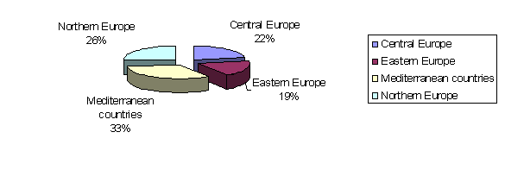

Most of the trade unions involved in the survey belong to the trade union networks of the European capital cities which have been collaborating as an informal network for about 25 years.

At the Standing Conference of the trade unions of the European Capitals, more than 20 organisations have always taken part, and they have in fact formed an Informal Network of Associations.

At the XIII Conference, the need was felt to create an acronym for this network – the European Capitals’ Trade Unions Network: ECTUN – as an interface of the acronym of the Network of Business Enterprises of the European Capitals (the Association of Interprofessionals, Employers, Businessmen: OPCE [Organizações Patronais Interprofissionais das Capitais Europeias]) with which a path of collaboration began.

It must be understood that the ECTUN has always been, and remains, an informal network, with an unchanged functioning structure, and that in fact all the trade union organisations that have attended at least one Conference can be considered as members.

As already mentioned, to understand how the trade unions of the European capitals operate in their areas, it is necessary to understand their functioning mechanism. In fact, although they have the same objectives, they often operate and act in their own areas in different ways from each other, and for the European trade union members, also to gain positive input from the same, it is extremely important to reinforce their own knowledge of the functioning of the various trade unions in the European capitals. Reinforcement of knowledge on the functioning of the diverse associations also allows for greater understanding of the problems and the strong points of each area.

With regard to how the trade unions interviewed are organised structurally, 90% of the local trade unions also have a national organisation of reference: they are therefore organised at both national level, and at regional and local level. In addition, 70% belong to sector federations (composed of a minimum of 7 up to a maximum of 22 associations).

Local structure of the trade unions interviewed
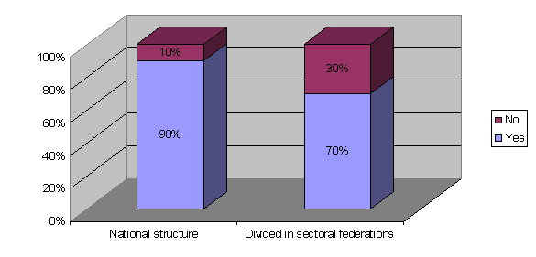
In consideration of the fact that almost all the local trade unions of the survey also have a national organisation of reference, it is extremely important to consider their level of independence in respect of the higher structure. However, it can be seen that the local organisations have wide autonomy. In fact, 60% of the local trade unions have total independence – decision-making, financial, negotiating and organisational independence – in respect of the national structures, while the remaining 40%, although having considerable independence, are nevertheless slightly limited in some sectors.
Since most of the trade union organisations are members of the relative federations, according to professional sector, and they have wide autonomy in respect of the national structures, it is useful to understand the type of relationship they have, at local level, with the employers' associations and the local authorities. In fact, this aspect will allow for greater understanding of their methods and actions in favour of the workers, and their degree of participation in public governance. To this regard, 90% of the local trade unions have a direct relationship with the local and regional authorities of reference. In the same way, in 90% of cases, the local trade unions dialogue directly with the employers' associations of their local area. It is also useful to understand the level of institutionalisation and structuring of the dialogue with the employers' associations and the local authorities. In fact, the survey has revealed that bodies composed of trade unions and local authorities exist at local level in only 40% of the cases examined, while the percentage is higher – 63% - for bodies composed of local trade unions and employers' associations. The important figure, for understanding the extent of trade union dialogue at local level, is that in 85% of cases there are trilateral bodies composed of local authorities, employers' associations and trade unions.

Level of institutionalisation of trade union dialogue - Existence of bipartite/tripartite bodies at local level
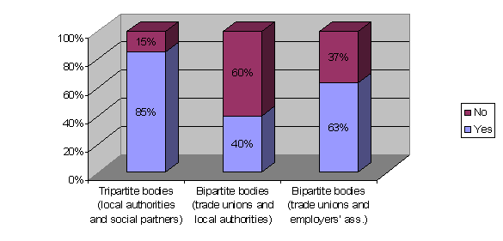
The general results of the survey are positive in this sense: in fact, in 79% of cases, the procedures for consultation between trade unions, local authorities and employers' associations at local level generally produce positive results in terms of agreements reached. The consultation process generally regards all aspects linked to work, to social policies and to local development.

Results of consultations between trade unions, local authorities and employers' associations
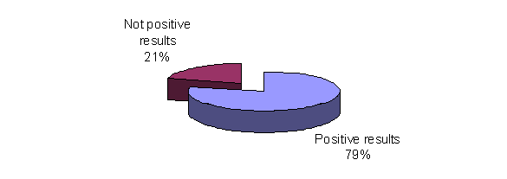
However, although the results are generally positive, a series of critical aspects exist in respect of the trade unions' effective active participation in these bodies: in fact, it has been found that the trade union's role is often limited to that of mere consultation. More specifically, for example, some countries have pointed out that consultation with the trade unions often represents a purely formal procedure, required before the implementation of legal obligations, and not, in fact, a process of social dialogue (e.g. in Spain).

2. Capitals, Regions and the Europe 2020 Strategy
At the presentation of the Europe 2020 Strategy, expectations were high. However, a first assessment shows that the subjects concerned, also due to external factors linked to the economic and financial situation, have not yet succeeded in reaching the expectations. To this regard, the ETUC (European Trade Union Confederation) has recently disclosed the results of a questionnaire which shows that most of the national trade unions which are Confederation members maintain that the strategy has merely a symbolic political value devoid of obligatory and binding criteria and objectives, unlike those contemplated by the austerity and deficit reduction measures.
For greater understanding of the role of the local trade unions in connection with the Europe 2020 Strategy, it is useful to know the government level which corresponds to the single duties and responsibilities in respect of the issues addressed by the targets. The analysis of the answers has revealed that competence is generally shared between national and local governments. In about half of the cities analysed, employment, the sphere in which important targets are pursued, falls exclusively within the competence of the central governments, while in the other 50% of cases, this responsibility is also shared at local and regional level. Also in the case of education, responsibility and power is shared between the various levels of government in about half of the cities analysed. In most cases, social policies are also the concern of local government. As far as concerning transport, competence is shared between the diverse levels of government in two thirds of the cities, as also for the environment.
Distribution of authority between the diverse levels of government in the cities of the sample
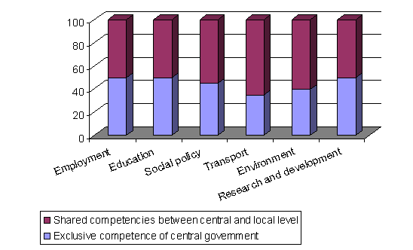
It has been found that the Europe 2020 Strategy, at least its general targets, is known in the European countries: this trend is confirmed by the fact that 76% of the trade unions of the capitals know the targets well or fairly well. However, 24% know little of nothing of the Strategy.

Level of knowledge of the issues addressed by the Europe 2020 Strategy
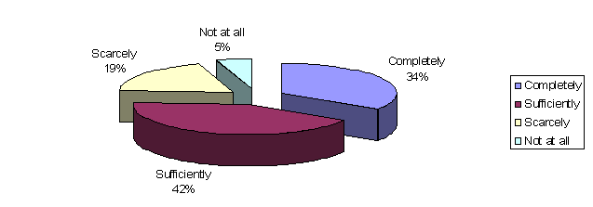
The most well known of the targets is that regarding employment, with 90%, followed by research and development, environment, and education with 70%. On the other hand, the single targets fixed by the Strategy for each country are less well known: in fact, 63% have little knowledge, and only 37% have fair knowledge. This shows that only the general lines and principles of the Strategy are known, rather than its specific details.

Level of knowledge of the specific targets of the Europe 2020 Strategy outlined for each country
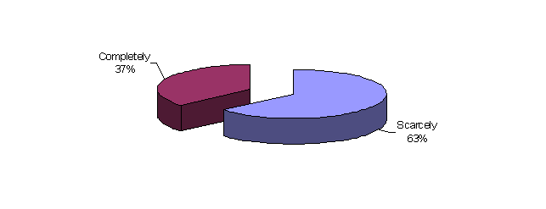

Level of knowledge of the targets of each of the issues addressed by the Europe 2020 Strategy
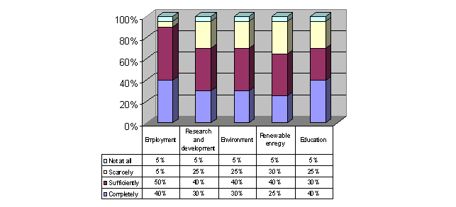

The European countries, as from the moment immediately after the launch of the Strategy, started to develop national plans and policies aimed at reaching the targets. To this regard, in fact, 90% of the countries analysed have adopted national policies aimed at reaching the targets set by the Strategy. At local level, however, the percentages are lower: in 70% of cases there are local policies aimed at reaching the Strategy targets.

Existence of policies aimed at reaching the targets of the Europe 2020 Strategy in each area
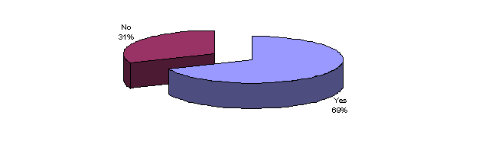
It is important to note that the policies are strictly linked to the area of reference, and that particular attention should be paid above all in the countries most recently included in the EU. In the area of Bucharest, in Romania, for example, although there are no precise policies yet, they will very probably be defined in the near future and they will regard particular aspects such as the disadvantaged areas and the mining areas. In Bulgaria, in 2012 the City Council of Sofia, thanks to its wide participation in civil society, adopted its own strategy entitled "The Future of the Europe 2020 Strategy - The Vision of Sofia". Sofia City Council was the first in Bulgaria to adopt its own position and strategy for reaching the targets. While in Vilnius, in Lithuania, the National Programme of Development 2014-2020 was drawn up.
The European Union has always recognised and fostered active participation on the part of the trade unions and of civil society in the execution of a shared strategy aimed at reaching the targets. In 68% of cases, the local trade unions are actively involved in the policies aimed at the pursuit of the Europe 2020 Strategy. However, only 15% of these cases maintain that their involvement is adequate, while the other 85% believe it should be increased.
Level of involvement of the local trade unions in the pursuit of the Europe 2020 Strategy targets
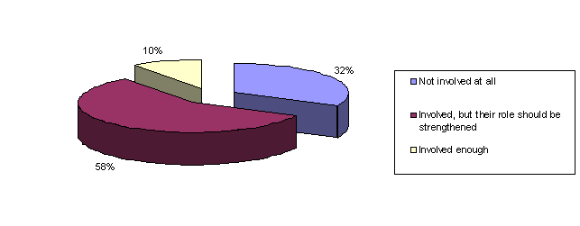
In addition to the trade unions, other organisations of civil society play an important role within the Strategy. In 90% of the cases, the employers' associations, the NGOs and the local authorities are also actively involved in the policies. The targets fixed by the strategy are many, and every area, albeit with similar problems, has different features and priorities. However, although there are some small differences, the priorities for the local trade unions are to increase the employment rate, to reduce the poverty rate in the population, to reduce the early school leaving rate and to increase energy efficiency.

Assessment of the importance of the EU 2020 Strategy targets for the local area
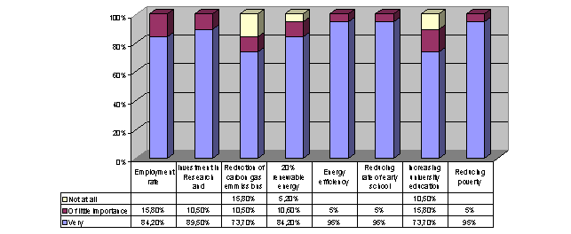

Active role of the local trade unions in the pursuit of the Europe 2020 Strategy targets
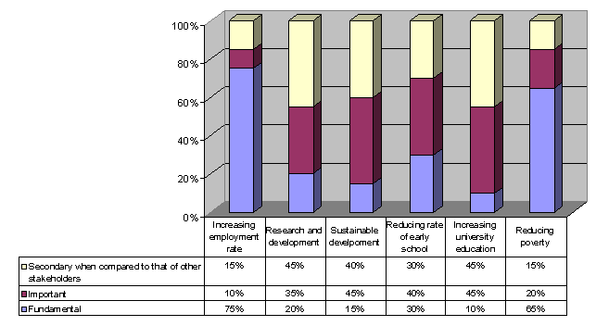

As indicated by the European Union, the role of the trade unions for reaching the Strategy targets is extremely important. To this regard, the local trade unions' role is fundamental, especially in pursuit of the employment and poverty reduction targets.
Theoretically, therefore, although tools and policies have not been adopted at European level such as to consider the effective attainment of the Europe 2020 Strategy targets, the trade unions consider these targets as important. However, it must be noted that for 45% of the local trade unions there are other aims of primary importance that have not been sufficiently considered. For example, the trade unions have pointed out the need to develop mechanisms which can promote: the development of employment, especially for the young, and guarantee dignified work; the defence of the social function of the State; salary increases; greater commitment for public housing; effective equality of the sexes, especially in the workplace; reinforcement of apprenticeship; and greater social harmony. It is important to underline that the additional aims pointed out by the trade unions of the European capitals are strictly linked to the economic crisis in progress, which has in fact conditioned the evolution of the Europe 2020 Strategy, as well as the need to develop, at European level, a strong packet of social policies to guarantee workers and citizens.

3. Good practices and final considerations

As shown by the results of the survey, in many EU countries the regional and local administrations have responsibility and power for policies connected to the Europe 2020 Strategy, such as education, social policies and the environment. Awareness is therefore essential, at every government level, of the need to effectively implement the Strategy in the field, in order to foster "intelligent, integral and sustainable" growth, and of the need for all stakeholders to communicate with each other and to give their contribution towards achieving the necessary changes and towards translating the Union priorities into effective practical action.

To facilitate this, the EU Committee of the Regions, which has the task of contributing to mobilising the regional and local administrations, has established the Europe 2020 monitoring platform. This is a network of more than 150 regions and cities which collaborate to promote growth and employment, to exchange knowledge of good practices and to provide input for the debate on the EUROPE 2020 Strategy at EU level.

In addition, the Handbook on the Europe 2020 strategy for cities and regions, produced by the Committee of the Regions in close collaboration with the European Commission, illustrates how local and regional bodies con contribute to the implementation of the Strategy. The Handbook presents examples of good practices collected by the survey carried out by the Europe 2020 Observatory of the Committee of the Regions or entered in the databanks managed by the European Commission.

To involve the local and regional administrations and to allow them to contribute towards reaching the Europe 2020 targets, the European Commission has also made available an on-line networking platform.

In this context, the project C.Re.A.T.E.S. (Capital Regions and the 2020 European Strategy) decided to analyse the trade unions' position, role and level of involvement as regards contributing to achieving the targets set by the Strategy, as well as to identify new tools which can influence and improve local policies, favouring, for example, the workers' active participation in corporate life and development.

To this regard, some of the trade unions involved have emphasised the importance of reinforcing the common political and social dimension at European level in order to be able to reach the Europe 2020 targets: an ambitious strategy launched in a context of strong economic, financial and social crisis accompanied by austerity policies.

However, there is no shortage of examples of good practices developed at local level within the sphere of the Europe 2020 Strategy aims: more than half of the trade unions interviewed have reported successful experiences in their own areas, potentially transferable or reproducible in other contexts.

Reporting good practices at local level, deemed replicable in other contexts
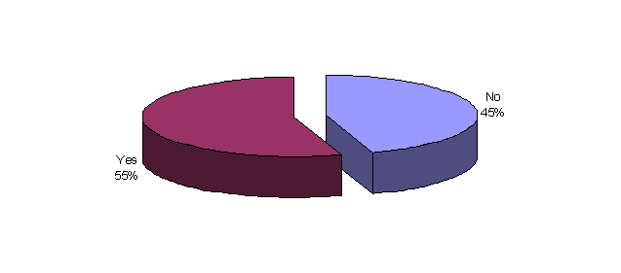

Within the sphere of the labour market and employment, several types of good practices have been reported, aimed at favouring the creation of new jobs: projects, agreements and new types of contracts. This is the case of Paris, where two new contractual forms have been introduced to favour the creation of jobs for the young: the contrat emploi d'avenir (“future contract”) and the contrat de génération (“generational contract”). The first type, introduced in 2012, has the purpose of favouring the professional employment of young people with low qualifications who are in a disadvantageous position as regards access to the labour market. The Contrat emploi d'avenir is a permanent contract, or a three-year contract, for which a State grant is given, amounting to 75% of the minimum inter-professional salary of the newly hired young people in the non-commercial sector, and 35% of the minimum salary of those hired in the commercial sector. The second contractual form, the Contrat de génération, introduced in 2013, has the aim of guaranteeing jobs for those considered as belonging to the weaker brackets of the labour market: the young and the senior workers. The purpose of the Contrat de génération is to stimulate the recruitment of the young and, at the same time, to guarantee the employment of older workers, thus ensuring the transmission of know-how between generations. For this type of contract, a government grant can be given in the case of people hired by small and medium companies as of 2012, under certain conditions.
Good practices have also been reported from London, represented by measures to favour the employment of the disadvantaged groups: the Intermediate labour market schemes. The said schemes involve a series of actions developed at local level which have the purpose of guiding the disadvantaged workers in the transition between unemployment and the world of work. The measures of the Intermediate labour market schemes include the promotion of work contracts with pay for 12 months, involving the supervision, training and assistance on the part of the authorities, and support in seeking work, training etc. Another interesting measure developed in London is the Young Person's Guarantee, which offers jobs or training to young people who have been unemployed for more than six months.
Good practices have also been reported in Rome, within the sphere of increasing employment: namely, the actions developed for placing the disabled and the disadvantaged in the province of Rome (the Progetto Sociale, the Progettazione Equal and the special agreement pursuant to art. 14 of Italian legislative decree 276/03). In addition, attention has been drawn to the agreements signed at local level for the abatement of taxation on production bonuses, workers' stabilisation, social security for the needy, and health and safety at work, against illegal labour employed in the execution of contracts, and for workers' training.
From Sofia, the project “FOR maternity benefits – AGAINST discrimination” has been reported; this has given good results in respect of the promotion of equal opportunities and the principle of non-discrimination, especially as regards maternity leave. Lastly, from Copenhagen, the importance of the strategy adopted in the Capital to increase employment and reduce unemployment has been reported.

Within the sphere of research and development, the Rete RedIRIS – the network of Spanish state universities and research centres – stands out as an example of good practice. It is an advanced communication network placed at the service of the Spanish scientific community. RedIRIS is financed by the Ministry of the Economy and managed by the Ministry of Industry. The network offers fundamental support for the exchange of information and the development of collaboration projects between the 450 public universities and public research centres which belong to RedIRIS. A similar project has been developed at local level at Île-de-France with the Pôle de compétitivité del Plateau de Saclay, constituted by universities, laboratories and companies which collaborate to foster research and the industrial development of the area.

With regard to the environment and sustainable development, another example of good practice is represented by the Agenda 21 régional of Ile de France: a local project which will promote the sustainable development of the Region. The Green Sustainability Rep in London is also worthy of note. This is a figure actively sustained by the trade unions in as much as involved in training and selection, and in the definition of the tasks entrusted to the trade unions.

With regard to good practices aimed at reducing the population at the risk of poverty or social exclusion, the positive impact of the Progettazione Equal and of the Progetto Social has been reported from Rome, as well as agreements signed at local level on the reform of home assistance, special tariffs based on income and family composition, and measures to guarantee basic food for the elderly. On the same line, in Paris the chèque mobilité has been introduced, which guarantees access to public transport at reduced prices for young people who are starting out on their first jobs.

The good practices reported by the Moscow trade union are of particular importance. They involve a series of synergetic and integrated actions in the various sectors, some already developed and others still in the development phase. An electronic transport system (BUS) has been developed in the historic centre, and at the same time the installation of 900 bicycle parks is planned, necessary for the city’s approximately 10 thousand bicycles, to favour sustainable transport. Special attention has also been paid to the question of urban liveability, and questionnaires have been delivered to citizens on this issue, with the result that the creation of new city parks is planned. Furthermore, in pursuit of "new development", a huge park is being planned in the riverside area, along which new apartments, cultural centres, offices and hospitals are intended to rise, simultaneously also creating new jobs. Together with the development of sustainable transport and urban liveability, the Moscow government has developed a whole series of tools to facilitate the life of its citizens in the e-government and e-health sectors; Muscovites will thus be able to take avail of diverse services, such as fixing an appointment with their doctor directly on-line, avoiding the need to move physically for this task. Lastly, special attention is given in the Region to the question of education, and to environmental sensitisation, which has also been regulated by a trilateral agreement between the trade union, the employers' associations and the Moscow government. The MTUF periodically organises a series of training seminars and activities on ecological and environmental issues.
The synergy between all these actions represents without doubt a model and a practice to be adopted.

Position de la CES sur la stratégie Europe 2020 – une évaluation, Adoptée au Comité executif de la CES le 5 et 6 mars 2013

